Practical 2

Shrisai Halankar

1. Log into root directory.



2. Add new users and set password for the same.

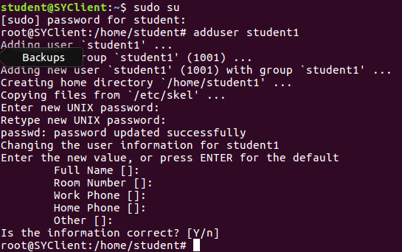

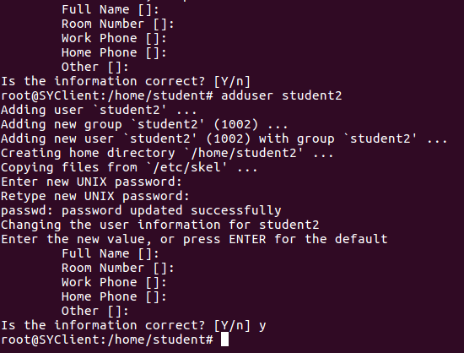

3. Log out from root.

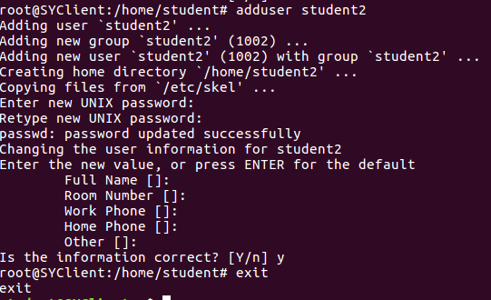

4. Login in the newly created users by loging in into the root directory.

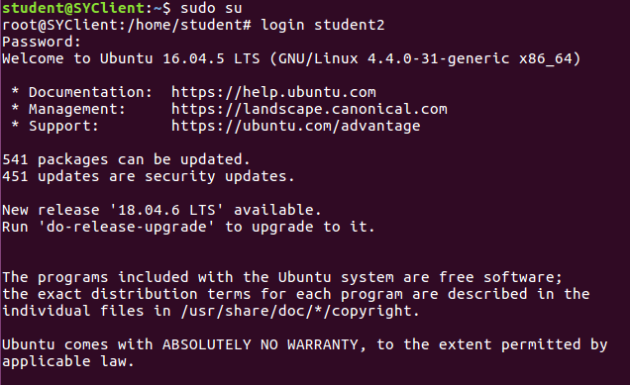

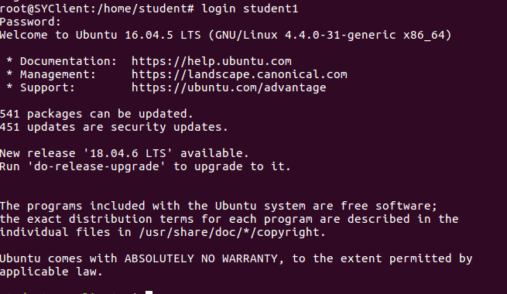

5. Log out of the newly created account.



6. Display the calendar of the current month of the current year.

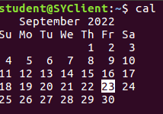

7. Display the calendar of the year 2009.

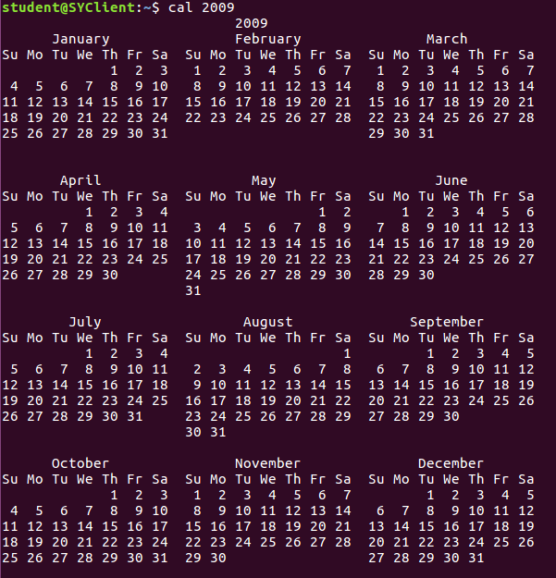

8. Display calendar of the month of June of the year 1998.

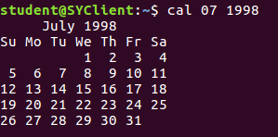

9. Display todays date.



10. Display date as dd/mm/yy



11. Display current hour minutes and seconds individually.

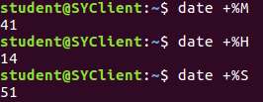

12. Display time in hours, minutes and seconds as HH:MM:SS.



13. Display day of the week.



14. Display abbreviated weekday.



15. Display abbreviated current month.



16. Display time in AM PM notation.



17. Display last two digits of the year.



18. Display the time and date on two different lines.



19. Calculate the following using bc command.

1) 6+7

2) 144/3

3) (8+2)\*5

4) 2^6

5)ibase=2 11001010

6) 12\*12

7)scale=2 25/7

8)(2+3)+8-4\*(6-3)

9)12\*12;12/6

10)obase=2 14

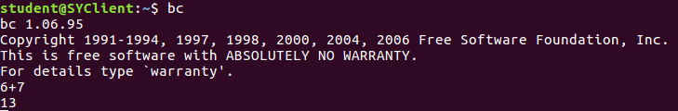

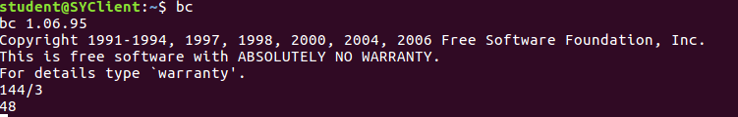

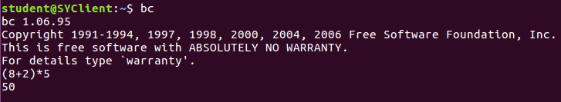

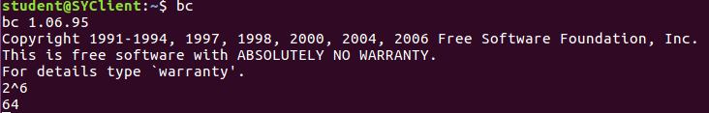

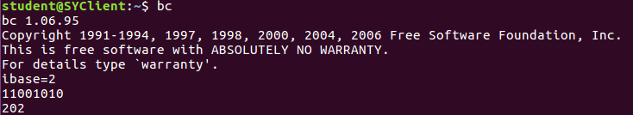

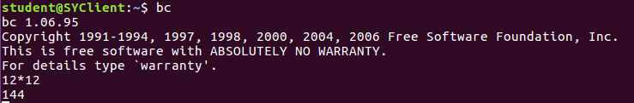

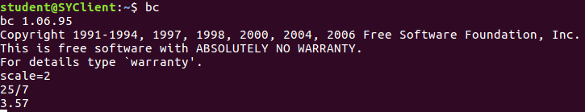

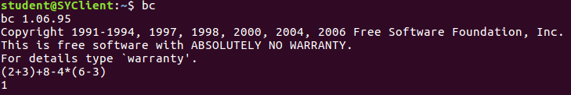

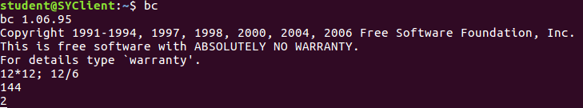

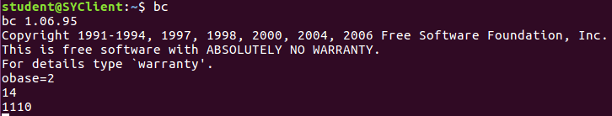

20. Display all the user currently logged in the system.



21. Display the login name of the current terminal.



22. Display all the user currently logged in the system with heading.



23. Display the terminal file of the current terminal.



24. Display the message on the terminal as hello world.



25. Display the message on the terminal as “hello world”.



26. what will be the output of the following:

1)x=10

echo The value of x is $x

2)str=”This is the first practical”

echo The string is $str

3)d=’date’

Echo “today`s date is $d”

4)echo “The number of users currently logged in are

‘who”’







